**ANNEX 2:**

POST-AWARD GENDER ANALYSIS TEMPLATE FOR ANALYSES FORMATTED AS A REPORT

**ANNEX 2:**

POST-AWARD GENDER ANALYSIS TEMPLATE FOR ANALYSES FORMATTED AS A REPORT

|  |
| --- |
| **ABOUT THIS TEMPLATE:**  *The template is recommended for implementing partners that prefer a report format or have conducted a more rigorous analysis with primary data collected. It is highly recommended to organize the report based on the project’s results framework.*  *When using this template, delete all instructions [shown in brackets] and replace all headings and text with your own content, adapted to the needs of the project. This template is based on the USAID Graphic Standards Manual and Partner Co-Branding Guide, revised in February 2020. To ensure that the report adheres to the most recent information and templates, refer to* [*USAID branding guidelines*](https://www.usaid.gov/branding) *and the* [*ADS Writing Guidelines and Style Guide*](https://www.usaid.gov/sites/default/files/2023-05/501mac.pdf)*.* |

|  |  |
| --- | --- |
| TABLE 2-1. SUGGESTED REPORT SECTIONS | |
| SECTION | DETAILS |
| EXECUTIVE SUMMARY  (1 page) | * Include a succinct overview of the most important findings, conclusions, and recommendations. |
| **INTRODUCTION** (up to 2 pages) | |
| BACKGROUND | * Briefly outline the purpose of the gender analysis. Summarize the breadth and depth of data collected. Note any limitations in data collection and how they may have affected the findings. |
| CONTEXT | * Provide an overview of the gender equality context in which the project will take place, integrating relevant sex-disaggregated data (further disaggregated by intersectional characteristics, when available) and noting where disaggregated data is unavailable. Identify the existing gender gaps and root causes of gender inequalities across identified marginalized groups, relevant to the activity. |
| **FINDINGS AND RECOMMENDATIONS** (up to 12 pages) | |
| FINDINGS BY OBJECTIVE/ INTERMEDIATE RESULT | * **Organize findings by project components (objective or intermediate results)** to make sure each finding can be readily associated with the relevant element of the project. * Present findings and data in a format that makes it easy for the project staff to insert them into the project’s Gender Equality Action Plan (GAP). Consider bolding major findings. Provide justification where appropriate by triangulating data sources. |
| RECOMMENDATIONS | * Provide concrete, actionable recommendations that are clearly linked to the associated findings. Recommendations may be presented in order of priority, either following each findings subsection or as a separate section. * Clearly link each recommendation to the associated findings to demonstrate the specific reasoning supporting the recommendation. * Include recommended prevention and mitigation strategies for any identified gender-related risks. |
| **ATTACHMENTS** |  |
| ANNEXES | Examples of common annexes include:  ● Gender Analysis Scope of Work  ● Additional information on methodology (optional)  ● References used for secondary data review  ● Primary data collection tools  ● List of consulted stakeholders (redacted as needed for confidentiality) |

The template starts on the next page



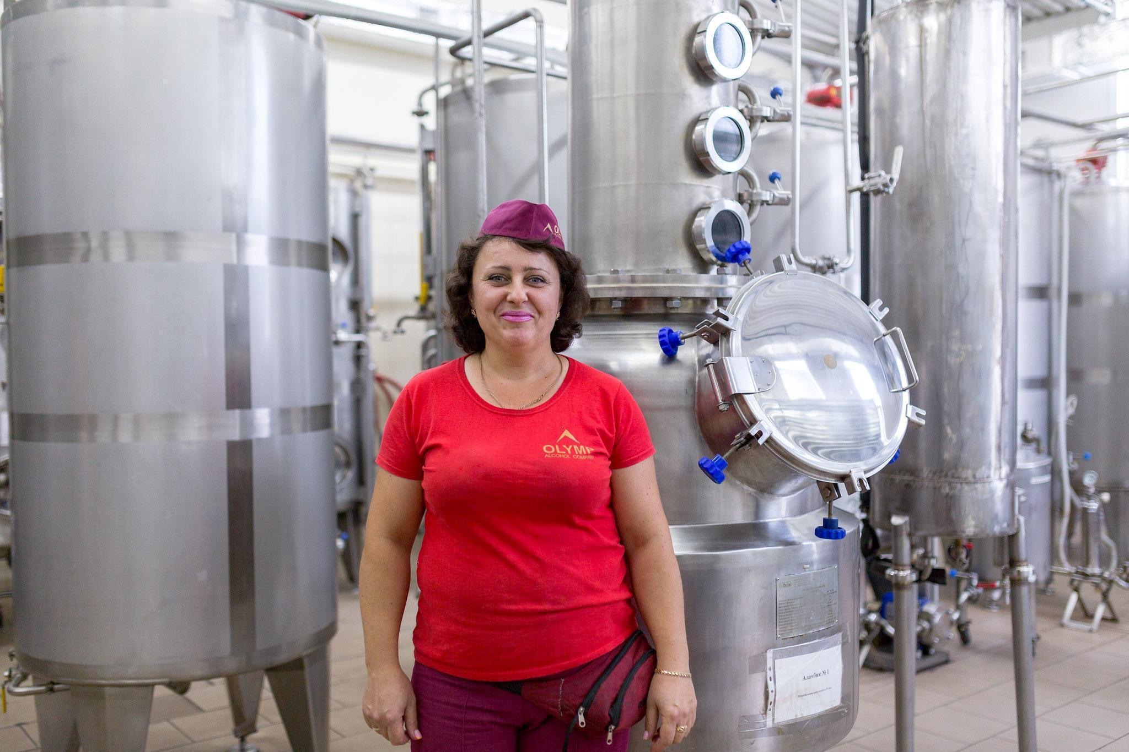

*Photo Credit: [Name]*

[PROJECT NAME GOES HERE]

[PROJECT] GENDER ANALYSIS REPORT

[Optional Subtitle Can Go Here]

[INSTRUCTIONS: DELETE THIS BOX IN FINAL REPORT TEMPLATE]

[The title should be informative, with no acronyms.]

[Change the cover photo to one that is relevant to the context, and update photo credit accordingly. To change the photo: 1. Right-click placeholder photo; 2. Select “Change Photo”; 3. Choose “From a File”; 4. Select desired photo from computer; 5. Click “Insert”]"

[PROJECT NAME GOES HERE]

[PROJECT] GENDER ANALYSIS REPORT

[Optional Subtitle]

[MONTH DAY, YEAR]

ACTIVITY NUMBER: [INSERT NUMBER, IF ONE EXISTS]

**DISCLAIMER** [if report is not authored by USAID]  
This document was produced for review by the United States Agency for International Development. It was prepared by [organization] for [USAID Mission/Bureau/Operating Unit]. The author’s views expressed in this publication do not necessarily reflect the views of the United States Agency for International Development or the United States Government.

**RECOMMENDED CITATION** [Insert Team Names (Last, First, Title/Suffix if applicable)].   
USAID/[Country], [Report Title]. Prepared by [organization]. [year].

TABLE OF CONTENTS

ACKNOWLEDGMENTS iii

ACRONYMS iv

EXECUTIVE SUMMARY 5

BACKGROUND AND CONTEXT 6

FINDINGS AND RECOMMENDATIONS 6

COMPONENT 1: [xxx] 6

COMPONENT 2: [xxx] 6

COMPONENT 3: [xxx] 6

ANNEXES 7

ANNEX A: GENDER ANALYSIS SCOPE OF WORK 8

ANNEX B: METHODOLOGY 8

ANNEX C: PRIMARY DATA COLLECTION TOOLS 8

ANNEX D: CONSULTED STAKEHOLDERS 8

ANNEX E: BIBLIOGRAPHY 8

*[Update the table of contents when you finalize the report: Select the text that says Table of Contents. A blue box should appear; select the arrow in the blue box at top left and select “update table.” Alternatively, right click on the table and then select “update field.”]*

# ACKNOWLEDGMENTS

*[Update based on the report. An example is provided below.]*

[Name], [Title], and [Name], [Title], researched and wrote this report with support from [Name], [Title], under the direction of [Name], [Title], [Organization]. Additional support was provided by [Name], [Title]. The authors developed this publication with guidance from the United States Agency for International Development, particularly [Name], [Title], [Office].

The team expresses its gratitude to USAID [office] and [office] and USAID missions in [Countries], with special thanks to [Name], [Name], [Name], [Name], [Name], [Name], [Name], and [Name].

For further information, please contact:

[Enter name and organization]

[Enter address]

[Enter Phone: +]

[Enter Fax: +]

# ACRONYMS

*[Update list based on acronyms used in the report. If an acronym appears in the body of the report, it needs to be referenced here. When using an acronym for the first time in the body of the report, spell it out completely. For example: “The United States Agency for International Development (USAID) is responsible for…”]*

|  |  |
| --- | --- |
| **ADS** | Automated Directives System |
| **DEC** | Development Experience Clearinghouse |
| **GBV** | Gender-based violence |
| **GenDev** | Gender Equality and Women’s Empowerment Hub |
| **SOW** | Scope of work |
| **USAID** | United States Agency for International Development |
|  |  |

# EXECUTIVE SUMMARY

[The Executive Summary should stand alone as a summary of the key sections of the report and should summarize the content of the full report without adding new information. The Executive Summary should be one page and should serve as a succinct overview of the most important findings, conclusions, and recommendations.]

# BACKGROUND AND CONTEXT

[This introductory section should be up to two pages and should include the following information:]

* Background: [Briefly outline the purpose of the gender analysis, including a summary of the project.]
* Methodology: [Summarize the type and depth of data collected, including whether the analysis is based on secondary data, primary data, or both. Note any limitations in data collection and how they may have affected the findings.]
* Context: [Provide an overview of the gender equality context in which the activity will take place. Integrate sex-disaggregated statistics that serve to highlight relevant gender gaps, such as in a summary table. Identify key data gaps that the project staff, partners, and USAID should be aware of. This section should continue to reference, and may be guided by, USAID’s domains of analysis (ADS 205.3.2).]

# FINDINGS AND RECOMMENDATIONS

[It is recommended that findings and recommendations be organized by project components (such as objectives or intermediate results). While USAID’s domains of analysis (ADS 205.3.2) should be referenced throughout the analysis, organizing findings based on the project’s key components is often a more user-friendly structure for project teams. Make sure applicable findings can quickly be associated with the relevant project component.]

## OBJECTIVE 1: [xxx]

* **FINDING.** [Present findings in a format that makes it easy for project staff to insert the data and findings into the Gender Equality Action Plan (GAP) and other project documents. Recommended techniques include bolding major findings and including a summary table. Synthesize and interpret findings to help end users apply the analysis, by (for example) identifying recent trends and prioritizing findings. Provide conclusions that explain the importance of the findings, creating a valuable connection between findings and recommendations.]
* **RECOMMENDATION.** [Provide concrete, actionable recommendations clearly linked to the associated findings. Recommendations may be presented and prioritized following each findings sub-section. Alternatively, recommendations may be presented as a separate section following the findings section. Clearly link each recommendation to the associated findings, making it clear to a reader why a recommendation is being made. If there are more than five total recommendations, identify the top five priority recommendations.]

## OBJECTIVE 2: [xxx]

* **FINDING 1**
* **FINDING 2**
* **…**
* **RECOMMENDATION 1**
* **RECOMMENDATION 2**
* **…**

## OBJECTIVE 3: [xxx]

* **FINDING 1**
* **FINDING 2**
* **…**
* **RECOMMENDATION 1**
* **RECOMMENDATION 2**

# ANNEXES

[Examples of common annexes]

|  |  |
| --- | --- |
| **ANNEX A:** | Gender Analysis Scope of Work |
| **ANNEX B:** | Methodology |
| **ANNEX C:** | Primary Data Collection Tools |
| **ANNEX D:** | Consulted Stakeholders |
| **ANNEX E:** | Bibliography |

## 

## ANNEX A: GENDER ANALYSIS SCOPE OF WORK

[Insert the final scope of work approved by USAID that guided the gender analysis team. Refer to the [Annex 11: Gender Analysis SOW template](https://www.genderlinks.org/sites/default/files/2024-12/Annex-11.-Gender-Analysis-SOW-Template.docx).]

## ANNEX B: METHODOLOGY

[Provide a more detailed description of the methodology, if not included in the main report. Include the extent of a desk review (how many sources consulted, by which category) and primary data collection (how many people and stakeholders were engaged, using what methods). Note any data limitations regarding who could be consulted, and describe how that might have affected findings.]

## ANNEX C: PRIMARY DATA COLLECTION TOOLS

[Include copies of interview and focus group guides.]

## ANNEX D: CONSULTED STAKEHOLDERS

[List date and time, stakeholders represented, interview method, and the name(s) of the interviewees (providing that their consent has been obtained).* The information can be listed in the following table.]

[Insert more rows if needed. Annex tables should be numbered using the letter identifier, as shown.]

|  |  |  |  |  |
| --- | --- | --- | --- | --- |
| TABLE D1. KEY INFORMANT INTERVIEWS | | | | |
| ID | DATE/TIME | ORGANIZATION | INTERVIEW METHOD | ATTENDEES* |
| 1 | [Date]  [Time (current time zone, like EST or PST)] | [The organization they work for or belong to, such as USAID or World Bank] | [The method used to conduct the interview (such as telephone call, virtual platform, or in-person meeting)] | [List all participants in the conversation and their titles]   * [Use a bulleted list] |

*[Remember to get the permission of individuals who are interviewed to use their names in the report. If a promise of confidentiality requires that people interviewed not be identified by name, then list the number of interviewees and their relationship to the research area: e.g., “20 female business owners in the automobile industry”; “three local government officials in the city of Herat, Pakistan”; or “10 USAID implementing partners in the food security sector.”]

## ANNEX E: BIBLIOGRAPHY

[List any documents reviewed, sites visited, or any other information sources accessed during the literature review. Sources should be referenced in the following way:

Last name, First Initial. (Year). Title of Document, Title of Source. Link (if website or accessed online).]